List Infographic Design

List infographic templates are generally straightforward–the goal is to make them more eye-catching than a basic list. Visuals like icons can replace bullet points, and creative fonts and colors can make each item stand out.

Numbering the points in your list will help your information flow. This list infographic template uses different colored circle icons to help each number pop from the page:

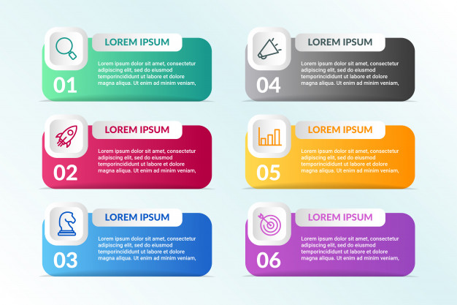

Comparison Infographic Design

A lot of people have trouble picking between multiple options. Whether you want to compare options in an unbiased way, or you want to make one option seem better, a comparison infographic can do that.

Typically, comparison infographic are split down the middle vertically or horizontally, with one option on each side.

For example, this comparison infographic template offers an unbiased comparison of two phones. The phone specs are listed down the middle of the infographic, making it easy to compare both options:

